**A MINI PROJECT ON QUIZ GAME**

**A CED & Startup Project Report**

**Submitted by:**

**MR. KISHAN KUMAR (0103IT171050)**

**Group No.-**

***In partial fulfillment for the award of the degree of***

**BACHELOR OF ENGINEERING**

**IN**

**INFORMATION TECHNOLOGY**

**at**

**LAKSHMI NARAIN COLLEGE OF TECHNOLOGY**

**KALCHURI NAGAR, RAISEN ROAD, BHOPAL (INDIA) – 462021**

**SESSION JAN MAY 2019**



**DECLARATION**

I hereby declare that the project entitled **“QUIZ GAME”** submitted for the B.E.(Information Technology) degree is my original work and the project has not formed the basis for the award of any other degree, diploma, fellowship or any other similar titles.

**Place: Name of the student:…………….**

**Date: Signature with date..........................**

**CERTIFICATE**

This is to certify that the project titled “**QUIZ GAME**” is the bona fide work carried out by **KISHAN KUMAR (0103IT171050)**  a student of B.E.(Information Technology) of Lakshmi Narain College of Technology, Bhopal affiliated to Rajiv Gandhi Proudyogiki Vishwavidyal, Bhopal, Madhya Pradesh (India) during the academic year 2019-20, in partial fulfillment of the requirements for the award of the degree of Bachelor of Engineering (**Information Technology** ) and that the project has not formed the basis for the award previously of any other degree, diploma, fellowship or any other similar title.

**Signature Faculty Coordinator:**

**Lakshmi Narain College of Technology**

**ACKNOWLEDGEMENT**

Though perseverance and enthusiasm combined with effort in the right direction can bring forth the thing called success. But the realization of the harsh reality that the path towards success is full of my riads, temptatious, impediments and pitfalls often proves to be disheartening in such situation, it is the able guidance of knowledgeable person that steers one through difficulties and help him achieve success.

I am highly obliged to express our deep sense of gratitude and grateful thanks to my erudite guide **Prof. Kamlesh sir** for her valuable guidance and support which led to the successful and timely completion of my seminar report.

I am secondly very thankful to our H .O. D, Dept. of ***Information Technology*** for his valuable suggestions & guidance. cheerful encouragement of all staff members of my department and my friends.

|  |  |
| --- | --- |
|  | **Table of Contents**  **Page No.** |
| **Title** |  |
|  |  |
| Title Page | i |
| Declaration of the Student | ii |
| Certificate of the Guide | iii |
| Abstract | iv |
| Acknowledgement | v |
| List of Figures | vi |
| List of Tables (optional) | vii |
| Timeline / Gantt Chart(optional) | viii |

1. **INTRODUCTION* 7**
   1. Problem Definition
   2. Project Overview/Specifications
   3. Hardware Specification
   4. Software Specification
2. **LITERATURE SURVEY 8**
   1. Existing System
   2. Proposed System
   3. Feasibility Study
3. **SYSTEM ANALYSIS & DESIGN 9_11** 
   1. Requirement Specification
   2. Flowcharts / DFDs / ERDs
   3. Algorithms and Pseudo Code
4. **RESULTS / OUTPUTS 34_37**
5. **CONCLUSIONS / RECOMMENDATIONS**
6. **REFERENCES 38**
7. **APPENDICES 12_33**
   1. Details of software/simulator if any
   2. Steps to execute/run/implement the project
   3. Coding if any

**List of figures**

**Fig:1 start**

**Fig:2 Options menu**

**Fig:3 Sub menu**

**Fig:4 Player name**

**Fig:5 Question and answer**

**Fig:6 Exit**

**INTRODUCTION**



This 'QUIZ GAME' Project is designed for a question in which you can generate and manage a simple database for questions. The question number is automatically generated by the software and is stored in a binary file by the name 'QUESTION'. This data base is basically used as a MASTER file to be used as a look-up table for information like Quiz Option, Sub Menu, either C**omputer/Mathematics/Science** or **General** and the Return. In this software you can ask for any Menu on the basis of the Menu Question will be asked to the user & the user get 10 sec for answering the question. If the user is correct the he get 10 points on every question. If he is incorrect then he lost the game & game is closed.

**ABSTRACT**

The sole intention behind the consideration of this Project is to generate and manage a simple database for question.

This project is developed considering “QUIZ” information keeping context of the customer in mind.

Here, data is stored in a binary file by “QUESTION” and this database is basically used as MASTER file. Reports are designed on the basis of customer’s stay and payments made by the customer.

**SPECIFICATION/REQUIREMENTS:**

**1] Hardware:**

* + - * 1.7 GHz Pentium IV
      * 64 MB RAM
      * A Hard-drive space for storing questions.

**2] Software:**

* Operating System: Windows XP Service Pack 1
* Dev++ compiler.
* **TECHNOLOGY USED:**

**1] Front end:**

* + C++

C++ is an object oriented programming language. It is a superset of c language. C++ adds a number of object oriented features such as object inheritance , function overloading , operator overloading to C. C++ is a versatile language for handling very large programs.

* + Uses of C++

C++ can be used to build a variety of system such as editor, compiler, database, communication system.

C++ is easily maintainable and expandable.

**2] Back end:**

* Any file for storing database.

Many real life problems handle large volumes of data so we need to use some devices such as floppy disk or hard disk to store a data. The data is stored in these devices using a

concept of files. A file is a collection of data stored in a particular area on a disk. Programs can be designed to perform read and write operations on these files.

**DATA FLOW DIAGRAM**

COMPUTERS

MATHS

SCIENCE

GENERAL

DELETE

MODIFY

RETURN

**D.B.M.S**

**Coding**

**// PROJECT COMPUTER QUIZ**

**// INCLUDED HEADER FILES**

**#include<iostream.h>**

**#include<stdio.h>**

**#include<conio.h>**

**#include<ctype.h>**

**#include<stdlib.h>**

**#include<string.h>**

**void show_record();**

**void reset_score();**

**void help();**

**void edit_score(float , char []);**

**int main()**

**{**

**int countr,r,r1,count,i,n;**

**float score;**

**char choice;**

**char playername[20];**

**mainhome:**

**system("cls");**

**printf("\t\t\tC PROGRAM QUIZ GAME\n");**

**printf("\n\t\t________________________________________");**

**printf("\n\t\t\t WELCOME ");**

**printf("\n\t\t\t to ");**

**printf("\n\t\t\t THE GAME ");**

**printf("\n\t\t________________________________________");**

**printf("\n\t\t________________________________________");**

**printf("\n\t\t BECOME A MILLIONAIRE!!!!!!!!!!! ") ;**

**printf("\n\t\t________________________________________");**

**printf("\n\t\t________________________________________");**

**printf("\n\t\t > Press S to start the game");**

**printf("\n\t\t > Press V to view the highest score ");**

**printf("\n\t\t > Press R to reset score");**

**printf("\n\t\t > press H for help ");**

**printf("\n\t\t > press Q to quit ");**

**printf("\n\t\t________________________________________\n\n");**

**choice=toupper(getch());**

**if (choice=='V')**

**{**

**show_record();**

**goto mainhome;**

**}**

**else if (choice=='H')**

**{**

**help();getch();**

**goto mainhome;**

**}**

**else if (choice=='R')**

**{reset_score();**

**getch();**

**goto mainhome;}**

**else if (choice=='Q')**

**exit(1);**

**else if(choice=='S')**

**{**

**system("cls");**

**printf("\n\n\n\n\n\n\n\n\n\n\t\t\tResister your name:");**

**gets(playername);**

**system("cls");**

**printf("\n ------------------ Welcome %s to C Program Quiz Game --------------------------",playername);**

**printf("\n\n Here are some tips you might wanna know before playing:");**

**printf("\n -------------------------------------------------------------------------");**

**printf("\n >> There are 2 rounds in this Quiz Game,WARMUP ROUND & CHALLANGE ROUND");**

**printf("\n >> In warmup round you will be asked a total of 3 questions to test your");**

**printf("\n general knowledge. You are eligible to play the game if you give atleast 2");**

**printf("\n right answers, otherwise you can't proceed further to the Challenge Round.");**

**printf("\n >> You will be given 4 options and you have to press A, B ,C or D for the");**

**printf("\n right option.");**

**printf("\n >> You will be asked questions continuously, till right answers are given");**

**printf("\n\n\t!!!!!!!!!!!!! ALL THE BEST !!!!!!!!!!!!!");**

**printf("\n\n\n Press Y to start the game!\n");**

**printf("\n Press any other key to return to the main menu!");**

**if (toupper(getch())=='Y')**

**{**

**goto home;**

**}**

**else**

**{**

**goto mainhome;**

**system("cls");**

**}**

**home:**

**system("cls");**

**count=0;**

**for(i=1;i<=3;i++)**

**{**

**system("cls");**

**r1=i;**

**switch(r1)**

**{**

**case 1:**

**printf("\n\nWho is the prime minister of india?");**

**printf("\n\nA.SUSMA SWARAJ\t\tB.NITISH KUMAR\n\nC.NARENDRA MODI\t\tD.MANMOHAN SINGH");**

**if (toupper(getch())=='C')**

**{**

**printf("\n\nCorrect!!!");count++;**

**getch();**

**break;**

**}**

**else**

**{**

**printf("\n\nWrong!!! The correct answer is C.NARENDRA MODI");**

**getch();**

**break;**

**}**

**case 2:**

**printf("\n\n\nThe country with the highest environmental performance index is...");**

**printf("\n\nA.France\t\tB.Denmark\n\nC.Switzerland\t\tD.Finland");**

**if (toupper(getch())=='C')**

**{printf("\n\nCorrect!!!");count++;**

**getch();**

**break;}**

**else**

**{printf("\n\nWrong!!! The correct answer is C.Switzerland");**

**getch();**

**break;}**

**case 3:**

**printf("\n\n\nWhich animal laughs like human being?");**

**printf("\n\nA.Polar Bear\t\tB.Hyena\n\nC.Donkey\t\tD.Chimpanzee");**

**if (toupper(getch())=='B')**

**{printf("\n\nCorrect!!!");count++;**

**getch();**

**break;}**

**else**

**{printf("\n\nWrong!!! The correct answer is B.Hyena");**

**getch();**

**break;}**

**case 4:**

**printf("\n\n\nWho was awarded the youngest player award in Fifa World Cup 2006?");**

**printf("\n\nA.Wayne Rooney\t\tB.Lucas Podolski\n\nC.Lionel Messi\t\tD.Christiano Ronaldo");**

**if (toupper(getch())=='B')**

**{printf("\n\nCorrect!!!");count++;**

**getch();**

**break;}**

**else**

**{printf("\n\nWrong!!! The correct answer is B.Lucas Podolski");**

**getch();**

**break;}**

**if(count>=2)**

**{goto test;}**

**else**

**{**

**system("cls");**

**printf("\n\nSORRY YOU ARE NOT ELIGIBLE TO PLAY THIS GAME, BETTER LUCK NEXT TIME");**

**getch();**

**goto mainhome;**

**}**

**test:**

**system("cls");**

**printf("\n\n\t*** CONGRATULATION %s you are eligible to play the Game ***",playername);**

**printf("\n\n\n\n\t!Press any key to Start the Game!");**

**if(toupper(getch())=='p')**

**{goto game;}**

**game:**

**countr=0;**

**for(i=1;i<=10;i++)**

**{system("cls");**

**r=i;**

**switch(r)**

**{**

**case 1:**

**printf("\n\nWhat is the National Game of England?");**

**printf("\n\nA.Football\t\tB.Basketball\n\nC.Cricket\t\tD.Baseball");**

**if (toupper(getch())=='C')**

**{printf("\n\nCorrect!!!");countr++;getch();**

**break;getch();}**

**else**

**{printf("\n\nWrong!!! The correct answer is C.Cricket");getch();**

**goto score;**

**break;}**

**case 2:**

**printf("\n\n\nStudy of Earthquake is called............,");**

**printf("\n\nA.Seismology\t\tB.Cosmology\n\nC.Orology\t\tD.Etimology");**

**if (toupper(getch())=='A')**

**{printf("\n\nCorrect!!!");countr++;getch();**

**break;}**

**else**

**{printf("\n\nWrong!!! The correct answer is A.Seismology");getch();**

**goto score;**

**break;**

**}**

**case 3:**

**printf("\n\n\nAmong the top 10 highest peaks in the world, how many lie in Nepal? ");**

**printf("\n\nA.6\t\tB.7\n\nC.8\t\tD.9");**

**if (toupper(getch())=='C')**

**{printf("\n\nCorrect!!!");countr++;getch();**

**break;}**

**else**

**{printf("\n\nWrong!!! The correct answer is C.8");getch();**

**goto score;**

**break;}**

**case 4:**

**printf("\n\n\nThe Laws of Electromagnetic Induction were given by?");**

**printf("\n\nA.Faraday\t\tB.Tesla\n\nC.Maxwell\t\tD.Coulomb");**

**if (toupper(getch())=='A')**

**{printf("\n\nCorrect!!!");countr++;getch();**

**break;}**

**else**

**{**

**printf("\n\nWrong!!! The correct answer is A.Faraday");getch();**

**goto score;**

**break;**

**}**

**case 5:**

**printf("\n\n\nIn what unit is electric power measured?");**

**printf("\n\nA.Coulomb\t\tB.Watt\n\nC.Power\t\tD.Units");**

**if (toupper(getch())=='B')**

**{printf("\n\nCorrect!!!");countr++;getch(); break;}**

**else**

**{**

**printf("\n\nWrong!!! The correct answer is B.Power");**

**getch();**

**goto score;**

**break;**

**}**

**case 6:**

**printf("\n\n\nWhich element is found in Vitamin B12?");**

**printf("\n\nA.Zinc\t\tB.Cobalt\n\nC.Calcium\t\tD.Iron");**

**if (toupper(getch())=='B' )**

**{printf("\n\nCorrect!!!");countr++;getch();**

**break;}**

**else**

**{printf("\n\nWrong!!! The correct answer is B.Cobalt");goto score;**

**getch();**

**break;}**

**case 7:**

**printf("\n\n\nWhat is the National Name of Japan?");**

**printf("\n\nA.Polska\t\tB.Hellas\n\nC.Drukyul\t\tD.Nippon");**

**if (toupper(getch())=='D')**

**{printf("\n\nCorrect!!!");countr++;getch();**

**break;}**

**else**

**{printf("\n\nWrong!!! The correct answer is D.Nippon");getch();**

**goto score;**

**break;}**

**case 8:**

**printf("\n\n\nHow many times a piece of paper can be folded at the most?");**

**printf("\n\nA.6\t\tB.7\n\nC.8\t\tD.Depends on the size of paper");**

**if (toupper(getch())=='B')**

**{printf("\n\nCorrect!!!");countr++;getch(); break;}**

**else**

**{printf("\n\nWrong!!! The correct answer is B.7");getch();**

**goto score;**

**break;}**

**case 9:**

**printf("\n\n\nWhat is the capital of Denmark?");**

**printf("\n\nA.Copenhagen\t\tB.Helsinki\n\nC.Ajax\t\tD.Galatasaray");**

**if (toupper(getch())=='A')**

**{printf("\n\nCorrect!!!");countr++; getch();**

**break;}**

**else**

**{printf("\n\nWrong!!! The correct answer is A.Copenhagen");getch();**

**goto score;**

**break;}**

**case 10:**

**printf("\n\n\nWhat is the unit of measurement of distance between Stars?");**

**printf("\n\nA.Light Year\t\tB.Coulomb\n\nC.Nautical Mile\t\tD.Kilometer");**

**if (toupper(getch())=='A')**

**{printf("\n\nCorrect!!!");countr++; getch();**

**break;**

**}**

**else**

**{printf("\n\nWrong!!! The correct answer is A.Light Year");getch();**

**goto score;**

**break;}**

**case 11:**

**printf("\n\n\nWho won the Women's Australian Open Tennis in 2007?");**

**printf("\n\nA.Martina Hingis\t\tB.Maria Sarapova\n\nC.Kim Clijster\t\tD.Serena Williams");**

**if (toupper(getch())=='D')**

**{printf("\n\nCorrect!!!");countr++; getch();**

**break;}**

**else**

**{printf("\n\nWrong!!! The correct answer is D.Serena Williams");getch();goto score;**

**break;}**

**case 12:**

**printf("\n\n\nWhich film was awarded the Best Motion Picture at Oscar in 2010?");**

**printf("\n\nA.The Secret in their Eyes\t\tB.Shutter Island\n\nC.The King's Speech\t\tD.The Reader");**

**if (toupper(getch())=='C')**

**{printf("\n\nCorrect!!!");countr++; getch();**

**break;}**

**else**

**{printf("\n\nWrong!!! The correct answer is C.The King's Speech");getch();goto score;**

**break;}}}**

**score:**

**system("cls");**

**score=(float)countr*100000;**

**if(score>0.00 && score<1000000)**

**{**

**printf("\n\n\t\t**************** CONGRATULATION *****************");**

**printf("\n\t You won $%.2f",score);goto go;}**

**else if(score==1000000.00)**

**{**

**printf("\n\n\n \t\t**************** CONGRATULATION ****************");**

**printf("\n\t\t\t\t YOU ARE A MILLIONAIRE!!!!!!!!!");**

**printf("\n\t\t You won $%.2f",score);**

**printf("\t\t Thank You!!");**

**}**

**else**

**{**

**printf("\n\n\t******** SORRY YOU DIDN'T WIN ANY CASH ********");**

**printf("\n\t\t Thanks for your participation");**

**printf("\n\t\t TRY AGAIN");goto go;}**

**go:**

**puts("\n\n Press Y if you want to play next game");**

**puts(" Press any key if you want to go main menu");**

**if (toupper(getch())=='Y')**

**goto home;**

**else**

**{**

**edit_score(score,playername);**

**goto mainhome;}}}**

**void show_record()**

**{system("cls");**

**char name[20];**

**float scr;**

**FILE *f;**

**f=fopen("score.txt","r");**

**fscanf(f,"%s%f",&name,&scr);**

**printf("\n\n\t\t*************************************************************");**

**printf("\n\n\t\t %s has secured the Highest Score %0.2f",name,scr);**

**printf("\n\n\t\t*************************************************************");**

**fclose(f);**

**getch();}**

**void reset_score()**

**{system("cls");**

**float sc;**

**char nm[20];**

**FILE.f**

**f=fopen("score.txt","r+");**

**fscanf(f,"%s%f",&nm,&sc);**

**sc=0;**

**fprintf(f,"%s,%.2f",nm,sc);**

**fclose(f);}**

**void help()**

**{system("cls");**

**printf("\n\n HELP");**

**printf("\n -------------------------------------------------------------------------");**

**printf("\n ......................... C program Quiz Game...........");**

**printf("\n >> There are two rounds in the game, WARMUP ROUND & CHALLANGE ROUND");**

**printf("\n >> In warmup round you will be asked a total of 3 questions to test your general");**

**printf("\n knowledge. You will be eligible to play the game if you can give atleast 2");**

**printf("\n right answers otherwise you can't play the Game...........");**

**printf("\n By this way you can win upto ONE MILLION cash prize in RUPIES...............");**

**printf("\n >> You will be given 4 options and you have to press A, B ,C or D for the");**

**printf("\n right option");**

**printf("\n >> You will be asked questions continuously if you keep giving the right answers.");**

**printf("\n\n\t*********************BEST OF LUCK*********************************");**

**printf("\n\n\t*****C PROGRAM QUIZ GAME is developed BY KISHAN********");}**

**void edit_score(float score, char plnm[20])**

**{system("cls");**

**float sc;**

**char nm[20];**

**FILE *f;**

**f=fopen("score.txt","r");**

**fscanf(f,"%s%f",&nm,&sc);**

**if (score>=sc)**

**{ sc=score;**

**fclose(f);**

**f=fopen("score.txt","w");**

**fprintf(f,"%s\n%.2f",plnm,sc);**

fclose(f);}}

**Output:**

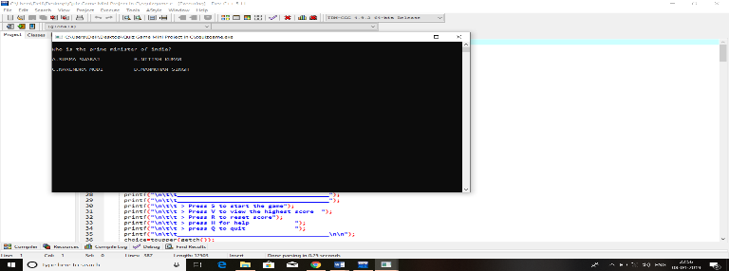

**Fig:1 Start**

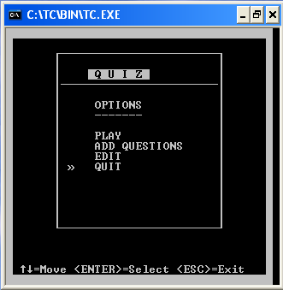

**Fig:2 Options menu**

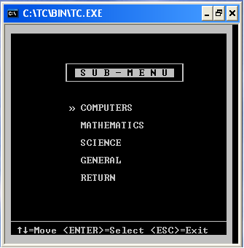

**Fig:3 Sub menu**

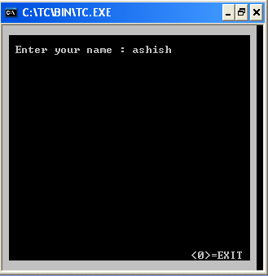

**Fig:4 player name**

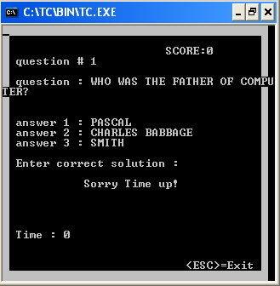

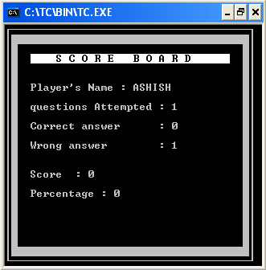

**fig:5 Question and score**

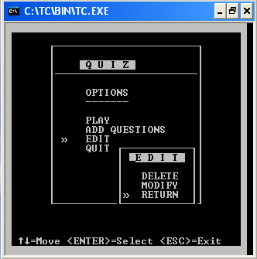

**Fig:6 Exit**

**CONCLUSION:**

The Quiz Game is capable to handle number of Question record having all their information stored in the backend file.

***REFERENCE***

[1]. Ariponnammal, S. and Natarajan, S. (1994) ‘Transport Phonomena of SmSel – X Asx’, Pramana – Journal of Physics Vol.42, No.1, pp.421-425.

In addition, following points should be complied with:-

1. Page numbering
2. Numbering of appendices, figures and tables and their reference in the text.
3. For general layout of report, any standard text book layout may be referred.